1. Doubling the side length of the square base will quadruple the area of the base. Thus the volume is quadrupled because the height is the same. B) $4(86,682,960)$
2. All of the listed figures have two pairs of congruent sides. E) NOTA
3. 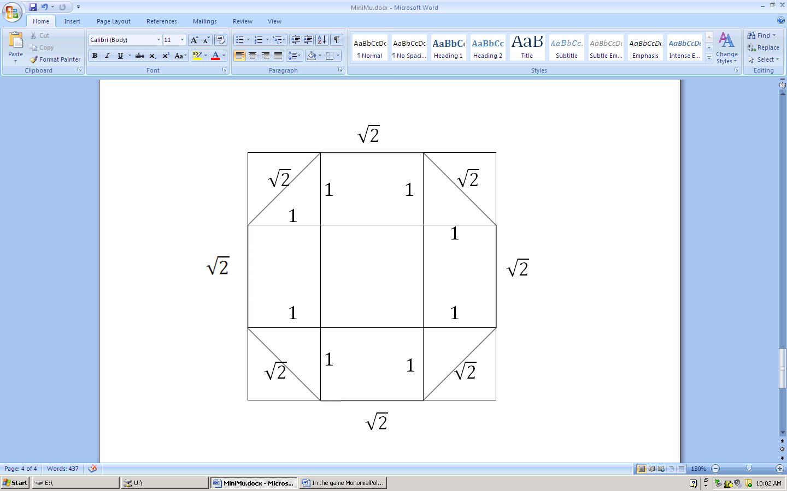The contrapositive of a conditional logically equivalent.  
    C) “If I do not save my Snapple for later, it rainstoday.”
4. The transformation is called a A) Dilation.
5. The two are B) Similar .
6. We split into 9 sections and add the areas. $\sqrt{2}+\sqrt{2}+\sqrt{2}+\sqrt{2}+2+\frac{1}{2}+\frac{1}{2}+\frac{1}{2}+\frac{1}{2}=4\sqrt{2}+4\left(\frac{1}{2}\right)+2=4+4\sqrt{2}$. Alternatively, we see the large square with side length $2+\sqrt{2}$ and subtract. ${(2+\sqrt{2})}^{2}-4\left(\frac{1}{2}\right)=6+4\sqrt{2}-2$ 
   , so the answer is D) $4+4\sqrt{2}$.
7. Since $x,y≠0$, we multiply the equation by $xy$ on both sides to get $4x+5y=3$. So the slope of the line is B $)-\frac{4}{5}$.
8. If you don’t know what an obelisk is or don’t know what the Washington Monument looks like, you can use Euler’s formula for polyhedrons: $vertices + faces = edges + 2$  
   Using the given information, $9+faces=16+2$. So the number of faces is D) $9$
9. It was Euclid that wrote the *Elements*. Euclid is considered the “Father of Geometry”.

C) Euclid

1. I) Counterexample: 2 skew lines.  
    II) Counterexamples: 2 coincident lines or 2 skew lines

III) Always true. There is no way for 3 point to not be coplanar.  
A) III only

$$r$$

$$\sqrt{13}$$

$$R$$

1. The longest line segment that can fit in an annulus is a chord of the outer circle that is tangent to the inner circle. Since $\sqrt{52}=2\sqrt{13}$, we can form a right triangle with the radii, legs $\sqrt{13}$ and $r$, and hypotenuse $R$.   
   So $13+r^{2}=R^{2}$ or $R^{2}-r^{2}=13$.

The area of the annulus is ${πR}^{2}-{πr}^{2}= π(R^{2}-r^{2})=13π$ E) NOTA

1. Folding in leg to leg will give the new 45-45-90 triangle the half the area of the original mast. The area of the original mast is $\frac{{\left(100\right)}^{2}}{2}=5000$. Thus the folded mast has area $\frac{5000}{2}=2500$. Alternatively you can notice the folded mast has legs of $50\sqrt{2}$, so the area would be $\frac{{\left(50\sqrt{2}\right)}^{2}}{2}$ or B) $2,500$.
2. $19×900=$ C) 17,100
3. Using the given information, we see that all six smaller triangles are equal in area. Thus there area of $∆COD=\text{area of} ∆DOB=k$. Alternatively, we can see that all the cevians are medians, so $CD=DB$, and since $∆COD\text{ and} ∆DOB$ have the same altitude, area of $∆COD=\text{area of} ∆DOB=$ A) $k$.
4. 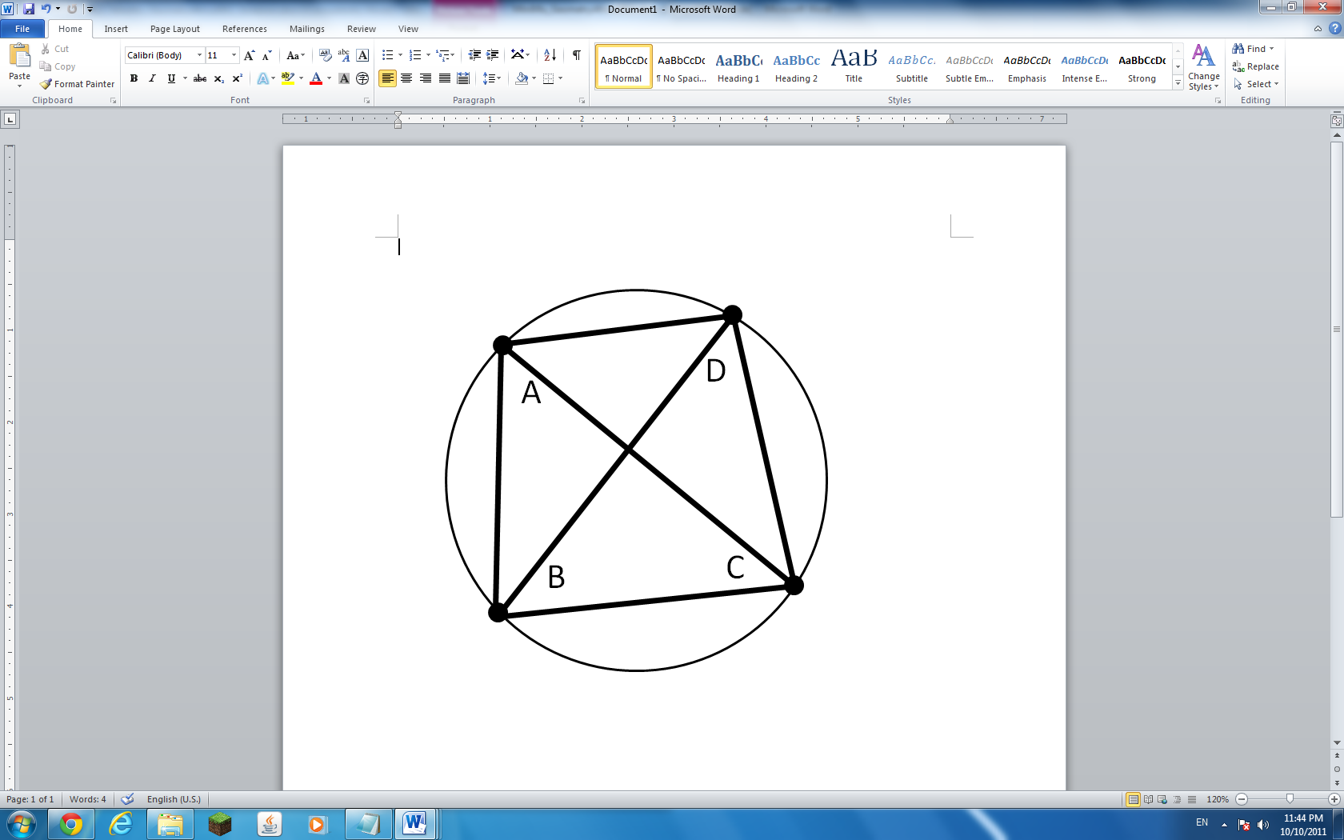Shoe-lacing, we get 19 for the area of the triangle. A) $19$
5. Notice that the quadrilateral $ABCD$ is symmetric about $\overset{⃡}{BD}$.   
   Therefore, $\overline{BD}$ is a diameter of the circle. $BD=400$.

$ABD$ is then a right triangle, ${AB}^{2}+{AD}^{2}={BD}^{2}$

$BD=100\sqrt{13}$ which contradicts itself. Therefore, the figure is impossible E

1. By Triangle Inequality, third side must be between $n$ and $3n$ exclusive. The integral sides can be $n+1, n+2, n+3,…3n-2, 3n-1$, so there are $2n-1$ possible values. E) NOTA
2. The minute hand is $90°$ from the 6 o’clock position. The hour hand is $1\frac{45}{60}×30°$ or $52.5°$ from the 6 o’clock position. Subtracting, we get $37.5°$ as the angle between the hands. The supplement of the complement of $37.5°$ is $180°-\left(90°-37.5°\right)$ or D) $127.5°$
3. Since there is a circle inscribed in the 19-gon, the polygon has a center (in this case it happens to be regular). Thus, $Area=apothem×semiperimeter$ (apothem=inradius). You can think of it as splitting the polygon into 19 triangles and using the $\frac{1}{2}bh$ formula 19 times. Area is $\frac{1}{2}×2×12.68$ or just $12.68$. Remember, we have to subtract the area of the circle. So the answer is D) $12.68-4π$.
4. We know that geometric mean of two numbers is always less than or equal to the arithmetic mean, with equality when both numbers are same. In other words, in a right triangle, the length altitude (geometric mean) the hypotenuse is always less than or equal to the length of the median (arithmetic) to the hypotenuse. Writing an inequality, $\sqrt{25000x}≤\frac{25000+x}{2}$. Rearranging, we see that $2\sqrt{25000x}-x≤25000$. Notice the left side of the inequality is just the numerical value of the profit, so the maximum profit you can make from this deal is $\$25,000$. Since we know equality is only reached if $x=25000$, you can achieve the maximum profit if you first pay the Nigerian prince A) $\$25,000$. *Warning: Do not actually do this in real life. It’s likely a scam.*
5. Euclid used induction to prove that there was an infinite number of prime in his 13-volume *Elements*. B) Induction
6. Direct application of angle bisector theorem. $\frac{25}{x-16}=\frac{20}{16}$, $x-16=20$ D) $36$
7. Using Power of a Point Theorem, $4×3=\frac{12}{5}x$. $x=$ C) $5$
8. These are the 3 classical constructions that have puzzled ancient geometers for centuries. They were proven to be impossible in the 1800s. D) I, II, and III
9. The answer is just the sum of the legs of the smallest Pythagorean triple. $3+4=$ A) $7$
10. The area is just $\frac{1}{2}AP-\frac{1}{2}ap=k$. $A,a$ are the apothem lengths and $P,p$ the perimeters. Since the outer pentagon is a 2x scale of the smaller pentagon, $\frac{1}{2}A=a$ and $\frac{1}{2}P=p$. Substituting, $\frac{1}{2}AP-\frac{1}{8}AP=k$, $AP=\frac{8}{3}k$. It is give $A=20$, so $P=\frac{8}{60}k=$ A) $\frac{2}{15}k$
11. I) Counterexample: a kite; False II) True III) Counterexample: an isosceles trapezoid;

C) II only

1. Solving for the three points, we get (2,2), (3,4), and (6,1). The coordinates of the centroid is $\left(\frac{x_{1}+x_{2}+x_{3}}{3},\frac{y_{1}+y_{2}+y_{3}}{3}\right)$, So the centroid is $\left(\frac{11}{3},\frac{7}{3}\right)$. $x+y=\frac{18}{3}$ 
    = $6$ E) NOTA
2. Notice that $\overline{AC}=\sqrt{6}+\sqrt{2}$ can be split into 2 segments of $\sqrt{6}$ and $\sqrt{2}$. We see that the triangle is actually a 30-60-90 triangle combined with a 45-45-90. So $m∠B=$ B) $75°$  
   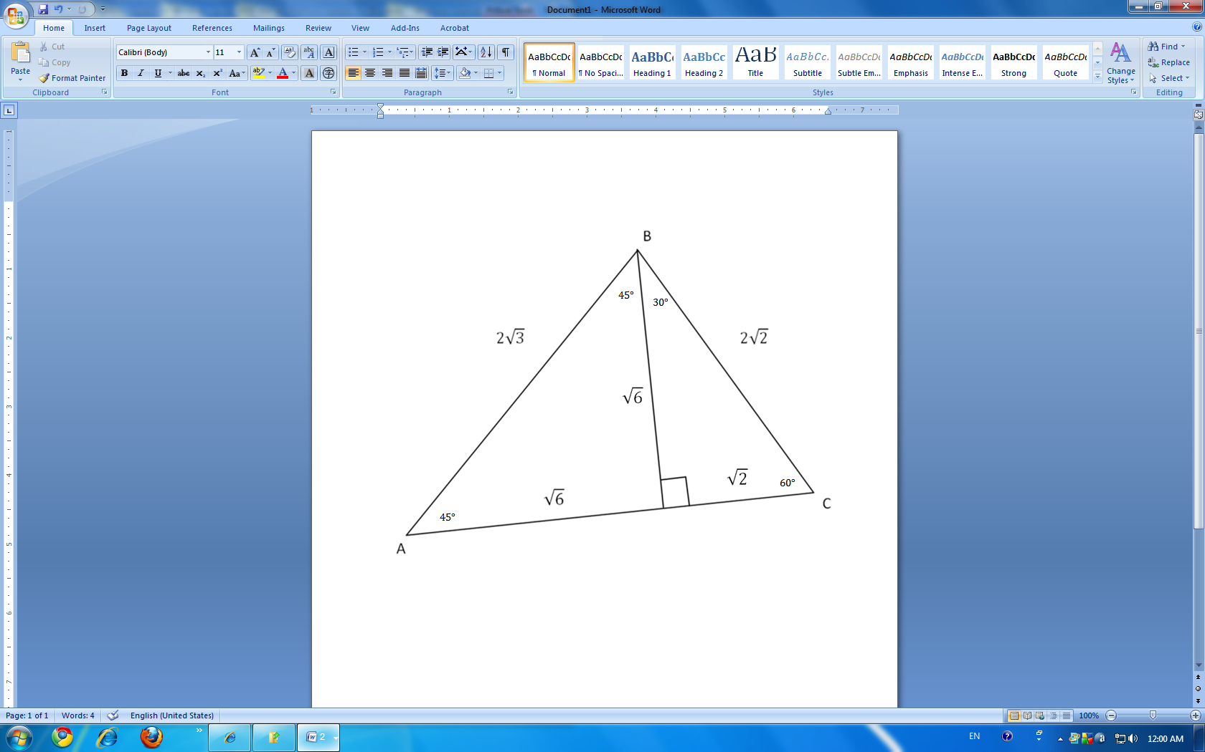
3. The operation shown is a logical conjunction, therefore the symbol should be A) $⋀$